Single Side Band Suppress Carrier


44254570 | محمد فيصل الشريف
44453892 | نواف مسلم المذكوري
44453879 | عبدالاله فايز المالكي
44201721 | تركي فارس الحليفي
44204081 | عبدالرحمن بندر العتيبي

Contents
Abstract 3
Introduction 4
Single-sideband suppressed-carrier 5
Single-Sideband (SSB) Modulation Method 6
Generation of SSB Signals 7
Power and Bandwidth Considerations 7
Types of SSB Transmission 8
Advantages of SSB SC 10
Simulation
Conclusion 12
References 13

Abstract
This article presents a detailed examination of single-sideband (SSB) modulation and its corresponding demodulation strategies. It thoroughly explains the core operating concepts, essential techniques, and circuit implementations associated with SSB systems. Emphasis is placed on its effectiveness as an analog amplitude modulation scheme, particularly in long-distance communication, where it optimizes bandwidth usage and transmission efficiency. The study also offers a comparative assessment between SSB and other modulation formats such as conventional AM, double-sideband (DSB), vestigial sideband (VSB), frequency modulation (FM), and phase modulation (PM). In addition, the article explores the wide range of practical applications where SSB analog amplitude modulation plays a significant role.

Introduction
Modulation is a foundational element in communication systems and is essential for addressing the difficulties associated with transmitting signals across great distances. In the modern, rapidly evolving communication landscape, efficient and dependable information exchange has become indispensable. With numerous communication platforms—such as messaging services, emails, video conferencing, and social networking tools—people can easily interact and share information in real time.
However, despite technological progress, long-distance signal transmission still presents challenges, particularly when relying on traditional transmission media like telegraph lines or conventional telephone systems. This is where modulation becomes vital. Modulation refers to the process of altering a carrier waveform so that it can effectively convey information from a transmitter to a receiver. By embedding the message signal into a carrier, modulation enables stable, long-range, and efficient communication.
Through the application of various modulation techniques, communication systems can significantly reduce the impact of issues such as attenuation, external interference, and noise introduced during propagation. Modulation not only supports signal strengthening and better propagation characteristics but also makes it possible to transmit multiple signals simultaneously by manipulating carrier frequency, amplitude, or phase. As a result, modulation ensures better bandwidth utilization and improves the overall reliability and performance of communication networks.
Among the numerous modulation strategies, single-sideband (SSB) modulation stands out due to its exceptional bandwidth efficiency and effectiveness in analog amplitude transmission systems. This article presents a detailed exploration of the operating principles of SSB modulation and explains the circuitry used for both generating and recovering SSB signals. A comparative evaluation is also provided, examining the strengths and limitations of several analog modulation techniques, including standard amplitude modulation (AM), double-sideband (DSB) modulation, vestigial sideband (VSB) modulation, frequency modulation (FM), and phase modulation (PM).
Additionally, the article investigates the wide range of practical fields where SSB modulation is extensively applied. From commercial broadcasting to marine and military communication systems, SSB has proven to be highly efficient in delivering reliable long-distance communication while requiring relatively low transmission power. Understanding these applications highlights the real-world importance of SSB and its continued relevance in modern communication technologies.
The structure of this article is organized as follows: Section II revisits the fundamental concept of modulation and its necessity in long-distance communication. Section III explains the theoretical basis and operating principles of SSB modulation, emphasizing its advantages in analog amplitude transmission. Section IV describes the hardware and circuitry used in SSB generation and detection. Section V provides a comparative study between SSB and other analog modulation techniques, outlining their merits and limitations. Section VI discusses practical applications of SSB across different sectors, and Section VII concludes with a summary of key insights and prospects for future developments in SSB communication technology.
Through this detailed discussion, readers will gain comprehensive insight into SSB modulation systems, their functionality, and their crucial contribution to reliable and efficient long-distance communication.
Single-sideband suppressed-carrier
Single-sideband suppressed-carrier (SSB-SC) transmission is derived from the double-sideband suppressed-carrier (DSB-SC) signal, which inherently consists of two symmetrical sidebands. Since both of these sidebands contain identical information, transmitting them simultaneously is unnecessary. By removing one of the sidebands and eliminating the carrier component, the system transmits only a single sideband. This technique is known as the Single Sideband Suppressed Carrier (SSB-SC) system. The corresponding spectral representation is illustrated in Figure 1.
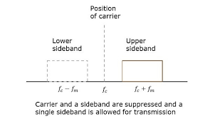
Fig 1. Carrier and Side band are Suppressed and a single side band is allowed for transmission.
In the illustrated spectrum, both the carrier component and the lower sideband are removed, leaving only the upper sideband for transmission. Conversely, it is equally possible to eliminate the carrier along with the upper sideband and transmit solely the lower sideband. In either case, the SSB-SC system transmits only one sideband. As a result, the power that would ordinarily be distributed between the carrier and the second sideband is instead concentrated into the single transmitted sideband, making SSB-SC a highly power-efficient modulation technique.
Single-Sideband (SSB) Modulation Method
Single-Sideband (SSB) modulation is an advanced form of amplitude modulation in which only one of the two sidebands produced during modulation is transmitted, while both the carrier and the other sideband are eliminated. Since the two sidebands in conventional AM carry duplicate information, transmitting only one sideband significantly improves spectral efficiency and power utilization. As a result, SSB is widely preferred in applications where bandwidth is limited and long-distance communication reliability is essential.

Generation of SSB Signals
SSB signals can be generated primarily through two well-known techniques:
1. Filter Method
In this method, a standard double-sideband suppressed-carrier (DSB-SC) signal is first generated. This DSB-SC signal contains both the upper and lower sidebands. A highly selective bandpass filter is then used to isolate and pass only one sideband—either the Upper Sideband (USB) or Lower Sideband (LSB)—while attenuating the other.
- Simple implementation conceptually
- Requires sharp, high-quality filters
- More suitable for high-frequency communication systems
2. Phase Shift Method (Hartley Method)
In this technique, the baseband signal and the carrier are phase-shifted by 90 degrees. By combining these components in a specific way, one of the sidebands naturally cancels out, leaving only a single sideband.
- Does not rely on sharp filtering
- Offers better performance at lower frequencies
- Requires precise phase-shifting networks
Power and Bandwidth Considerations
In SSB, only one sideband is transmitted, meaning:
- Bandwidth is reduced to half compared to conventional AM
- Power efficiency is improved, as power is not wasted on the carrier and unused sideband
- Systems can achieve greater communication range for the same power level
In single-sideband (SSB) modulation, both power utilization and bandwidth efficiency are significantly improved compared to conventional amplitude modulation techniques. In standard AM transmission, a substantial portion of the total transmitted power is wasted in the carrier and the redundant sideband, neither of which contributes additional information. However, SSB eliminates the carrier and one of the sidebands, ensuring that nearly all transmitted power is concentrated solely in the useful, information-bearing sideband. This makes SSB a highly power-efficient communication method, allowing reliable long-distance signal transmission even with relatively low transmitter power.
From a bandwidth perspective, SSB offers a major advantage. Conventional AM systems require a bandwidth equal to twice the highest frequency present in the modulating signal because both the upper and lower sidebands must be transmitted. In contrast, SSB requires only half of this bandwidth, since only one sideband is transmitted. This reduction in bandwidth leads to more efficient spectrum utilization, minimized channel congestion, and the ability to accommodate more communication channels within the same frequency band.
Overall, SSB modulation provides superior performance in terms of both power conservation and bandwidth management, making it especially valuable in systems where spectrum availability is limited and long-distance, energy-efficient communication is essential.
Types of SSB Transmission
Depending on which sideband is transmitted, SSB is classified as:
- Upper Sideband (USB) Transmission
Upper Sideband (USB) transmission refers to the form of single-sideband modulation in which only the frequency components located above the carrier frequency are transmitted. When a modulating signal undergoes amplitude modulation, two symmetrical sidebands are produced: the Upper Sideband and the Lower Sideband. In USB transmission, the carrier and the lower sideband are suppressed, allowing only the upper sideband to propagate through the communication channel.
The upper sideband contains the complete information of the original message signal; therefore, transmitting it alone does not result in any loss of data. By eliminating unnecessary frequency components, USB transmission significantly reduces bandwidth requirements—typically utilizing only half of the bandwidth needed in conventional AM systems. Additionally, since neither the carrier nor the redundant sideband is transmitted, the available power is more efficiently concentrated in the useful information-bearing signal.
USB transmission is widely used in high-frequency communication systems such as aviation radio communication, amateur radio, and long-distance professional communication networks. Its ability to enhance spectral efficiency, reduce interference, and improve signal strength over extended distances makes it a highly effective modulation approach in modern communication systems.
- Lower Sideband (LSB) Transmission
Lower Sideband (LSB) transmission is a form of single-sideband modulation in which only the frequency components lying below the carrier frequency are transmitted. During amplitude modulation, two mirror-image sidebands are generated: the Upper Sideband (USB) and the Lower Sideband (LSB). In LSB transmission, the carrier and the upper sideband are eliminated, and only the lower sideband is allowed to pass through the communication channel.

Despite the suppression of the carrier and the upper sideband, no information is lost because the lower sideband alone contains all the message signal information. By transmitting just one sideband, LSB significantly reduces the bandwidth requirement to half that of conventional amplitude modulation systems. Furthermore, it improves power efficiency by concentrating transmission power solely into the useful information-bearing components.
LSB transmission is commonly employed in various communication applications, including amateur radio, military communication systems, and certain high-frequency (HF) communication services. Its advantages include reduced spectrum usage, enhanced power utilization, and improved communication reliability over long distances, especially in environments where bandwidth is limited or signal quality is critical.
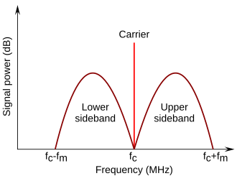
Both carry identical message content; the choice depends on system standards and application requirements.
Advantages of SSB Modulation
- Highly efficient bandwidth utilization
- Superior power efficiency
- Improved long-distance communication capability
- Reduced noise susceptibility due to lower transmitted power components

Simulation " using Multisim"
Circuit:
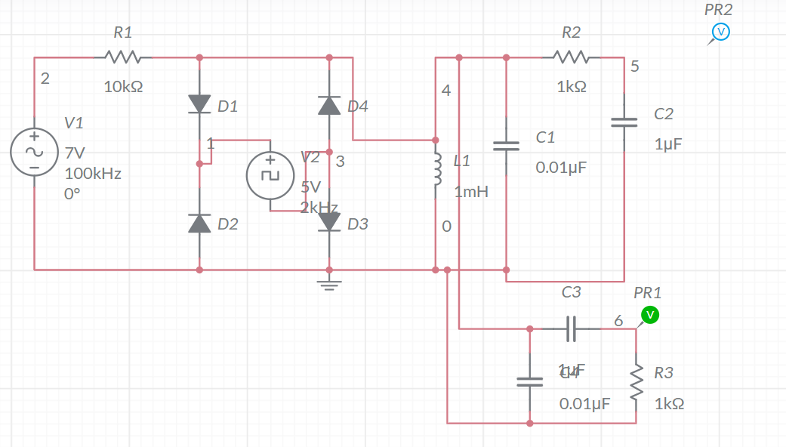

Figure:

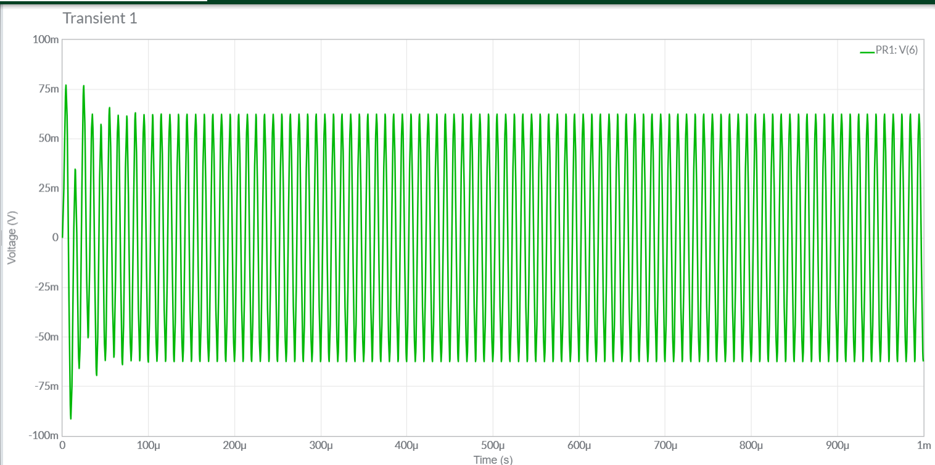

Conclusion
SSB modulation is a highly efficient technique that optimizes bandwidth usage while requiring less transmission power and offering superior noise resilience compared to conventional AM and DSB systems. Despite these advantages, it demands high-quality filters and precise frequency stability for proper operation. Due to its ability to support long-distance communication with reduced power and minimized bandwidth requirements, SSB is particularly well-suited for mobile and specialized communication systems, such as satellite phones and military networks. This makes it a preferred choice for communication equipment deployed in remote areas or scenarios where both power and spectral resources are limited.

References
[1] K. S. Shanmugam, “Digital and analog communication systems,” NASA STI/Recon Technical Report A, vol. 80, p. 23225, 1979.
[2] S. S. Haykin, Introduction to analog and digital communications. Wiley, 2007.
[3] J. B. Hagen, Radio-frequency electronics: circuits and applications. Cambridge University Press, 2009.
[4] J. G. Proakis and M. Salehi, Fundamentals of communication systems. Pearson Education India, 2007.
[5] M. C. Jeruchim, P. Balaban, and K. S. Shanmugan, Simulation of communication systems: modeling, methodology and techniques. Springer Science & Business Media, 2006.
[6] zeng xing wen, liu nai an, chen jian, et al., “High-frequency electronic circuits,” 2004.
[7] wangweidong, High Frequency Electronic Circuit. Electronic Industry Press, 2020.
[8] H. Yu, Communication Electronic Circuit. Tsinghua University Press Co., Ltd., 2005.
[9] L. Frenzel, Principles of electronic communication systems. McGraw-Hill, Inc., 2007.

